# CHAPTER 3: ADMINISTRATIVE CONSOLE

## Theory

WebSphere resources can be configured and managed via web based graphical tool. Although this tool is called officially as “Websphere Integrated Solutions Console”, you can usually find resources referring this console as “administrative console” or “admin console”.

Admin console is automatically installed system application called “isclite”. This application is installed on deployment manager in a network deployment environment or on application server in a stand-alone environment. Since it is a system application, you cannot see it in the list of applications. But, in case of troubles, you can uninstall and re-install this admin console using command line tool, “wsadmin”.

In the network deployment environment, you can perform administrative activities such as creating and managing applications and viewing logs for entire cell, where in stand-alone environment, you can take those activities only for that specific server.

Admin console has a simple layout to ease access to administrative tasks with different areas where you can resize as you wish.

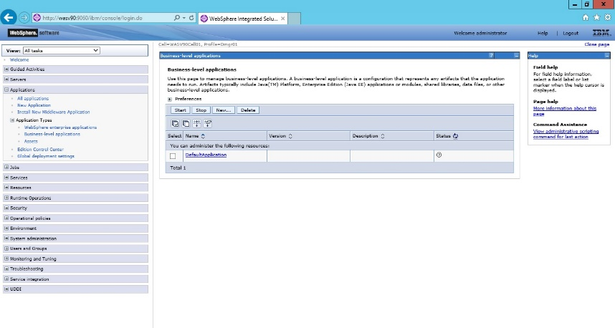  
Navigation tree has categorized view of all possible administrative tasks. As you click on a ‘+’, that menu item will expand and if you click on a ‘-‘ that menu item will collapse. Banner area is on the top of the page and contains three parts, that are, ’Welcome’ part showing the user logged in, ‘Help’ link which navigates to online help for Websphere Application Server and ‘Logout’ link that ends your session and redirects you to the login page. Work area is the place you take actions add, view, and change the configurations items. It contains also Messages part where you can see the outputs of your actions. But this part is just basic information, for further information, you should check the related logs.

In Websphere Application Server, certain configuration items should/can be defined for certain scope level. Possible scope levels from high to low are cell, cluster, node, server and application.

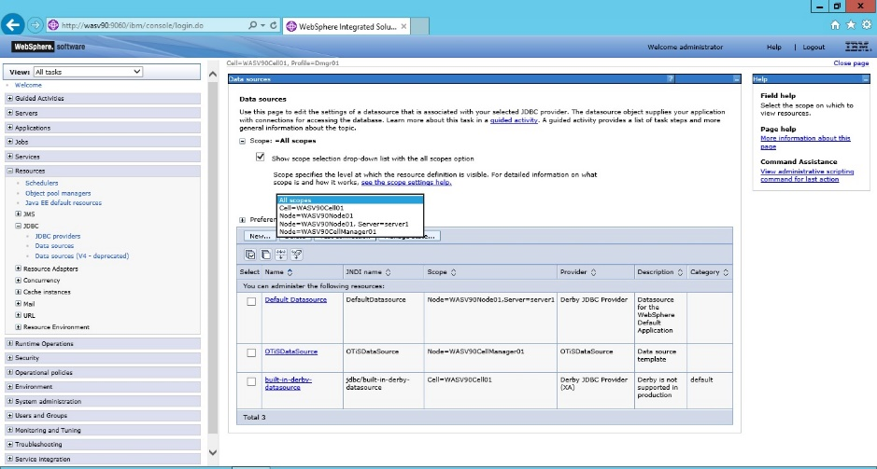

In admin console, you can choose the scope level as shown in the image and then click “Apply” to set the level. After that, the configuration item you changed will be effective for that level. Each scope level configuration is stored in different files (resources.xml) such as <profile_home>/config/cells/cell_name/nodes/<node>/resources.xml for node level or <profile_home>/config/cells/cell_name/resources.xml for cell level.

## AIM

When you complete the lab exercise, you will be able to take basic operations using graphical web interface, IBM Integrated Solutions Console.

The lab exercise contains following tasks:

1. Uninstall & Install Administration Console

2. Secure Administration Console

3. Stop & Start Application

4. Stop & Start Application Server

5. Restart & Stop Node Agent

6. Stop Deployment Manager

# Lab Exercise 3: ADMINISTRATIVE CONSOLE

|  |
| --- |
| Ins. Console  Secure Console  Stop Appl.  Stop App Srv.  Stop Node A.  Stop DMGR |

## Uninstall & Install Administration Console

1. **Start AgentNode**

## Stop & Start Application

## Stop & Start Application Server

## Restart & Stop Node Agent

## Stop Deployment Manager

Ins. Console

Secure Console

Stop  
Appl.

Stop App Srv.

Stop Node A.

Stop DMGR



**Task 1: Uninstall & Install Administration Console  
Step 1:** Make sure that Deployment Manager is up and running. If it’s stopped, please issue “startManager.sh” command to start it.

Note: Deployment Manager will be running by default. You can run “stopManager.sh” command to stop it. 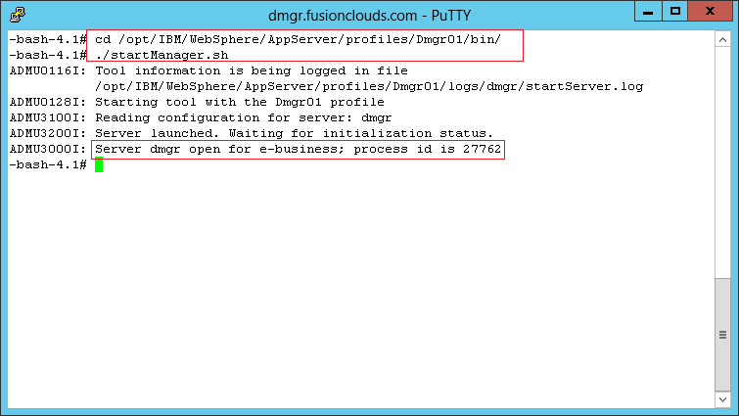

**Step 2.1:** In order to use “wsadmin” command, we need to have SOAP port. We can get this information from the administrative console or from configuration file. To check SOAP port from administrative console, we need to login.

**https://localhost:9043/ibm/console**

Ins. Console

Secure Console

Stop  
Appl.

Stop App Srv.

Stop Node A.

Stop DMGR



**Step 2.2:** Click on “System administration>Deployment manager” from left menu and then expand the “Ports” list in work area.

**Note:** Use localhost to access ibm console. You can also get lab environment hostname by running following command in the terminal:

**$ cat /etc/hosts**

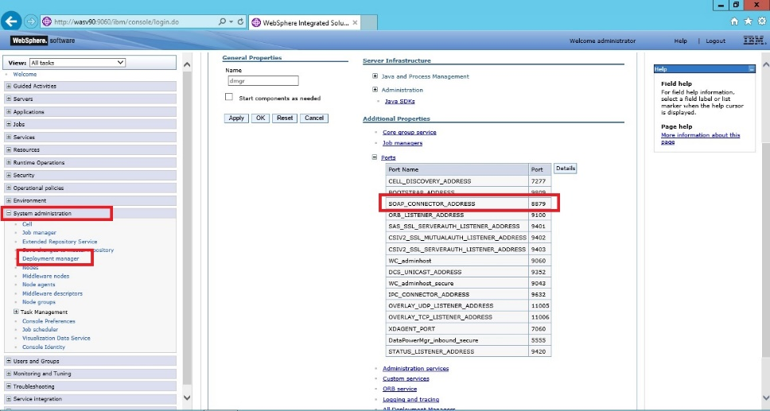**Step 2.3:** Or, you can check the SOAP configuration in “serverindex.xml” 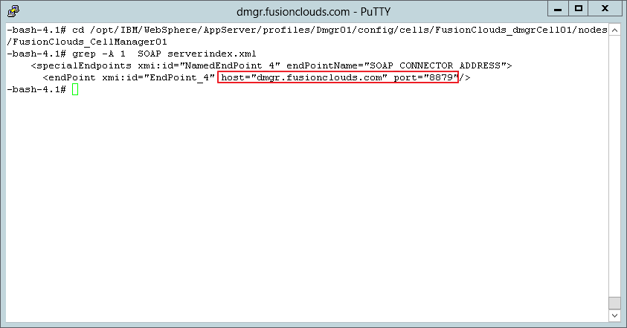

Ins. Console

Secure Console

Stop  
Appl.

Stop App Srv.

Stop Node A.

Stop DMGR



**Step 3:** From command line, run the following command under “/opt/IBM/WebSphere/AppServer/bin”:  
*“wsadmin.sh –host localhost –port 8879 –lang jython –f deployConsole.py remove”* 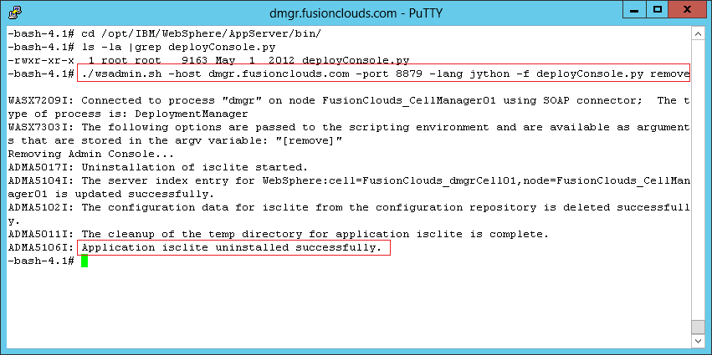

**Step 3:** When you try to reach the administrative console, you should get the error below.

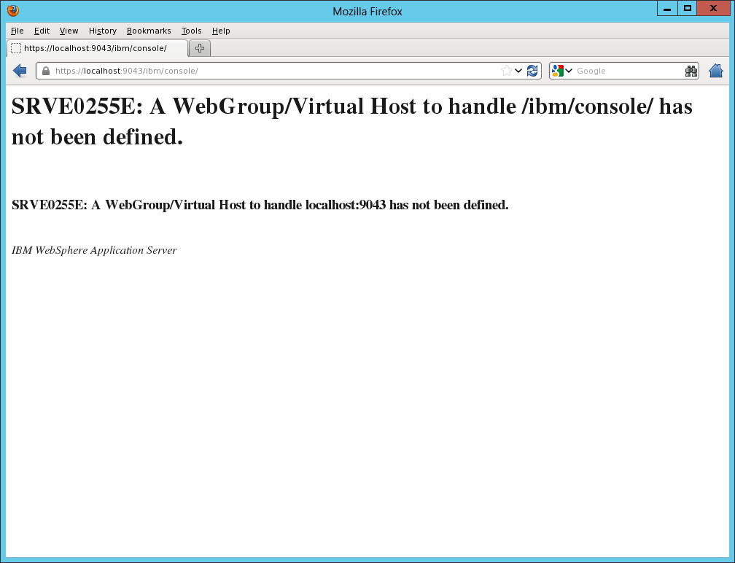

**Uninstall of administrative console is completed.**

Ins. Console

Secure Console

Stop  
Appl.

Stop App Srv.

Stop Node A.

Stop DMGR



**Step 4:** To install the Integrated Solutions Console again, issue the following command:

*“wsadmin.sh –host localhost –port 8879 –lang jython –f deployConsole.py install”***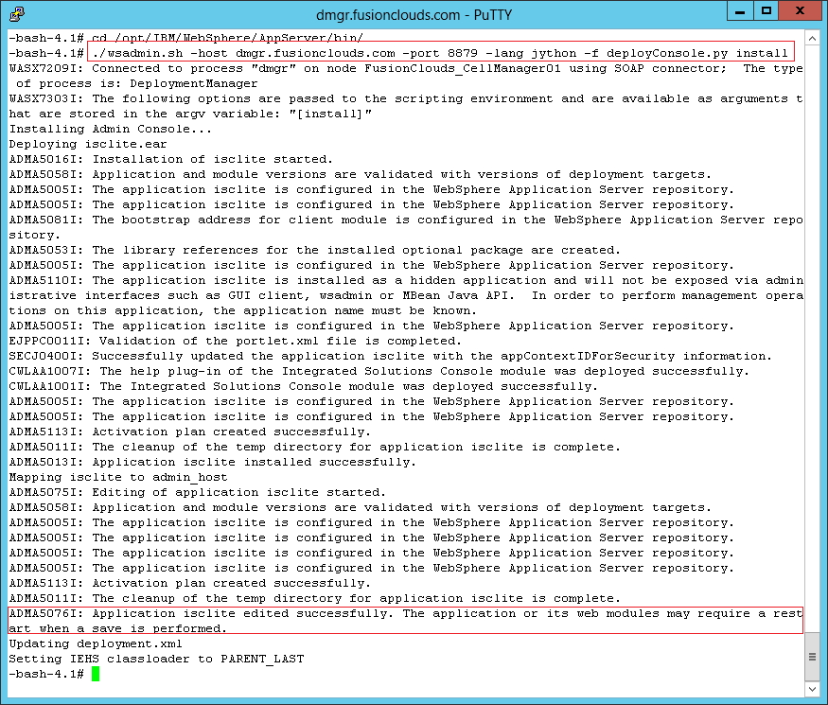**

Ins. Console

Secure Console

Stop  
Appl.

Stop App Srv.

Stop Node A.

Stop DMGR



**Step 5:** Restart the Deployment Manager as shown in the picture.

**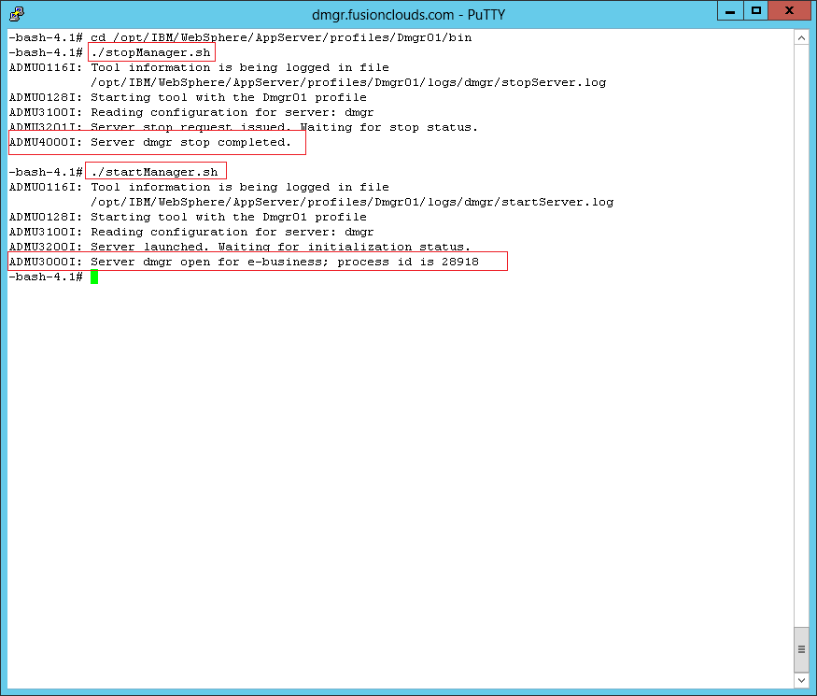  
 Step 6:** Check if the installation of the console application is successful. **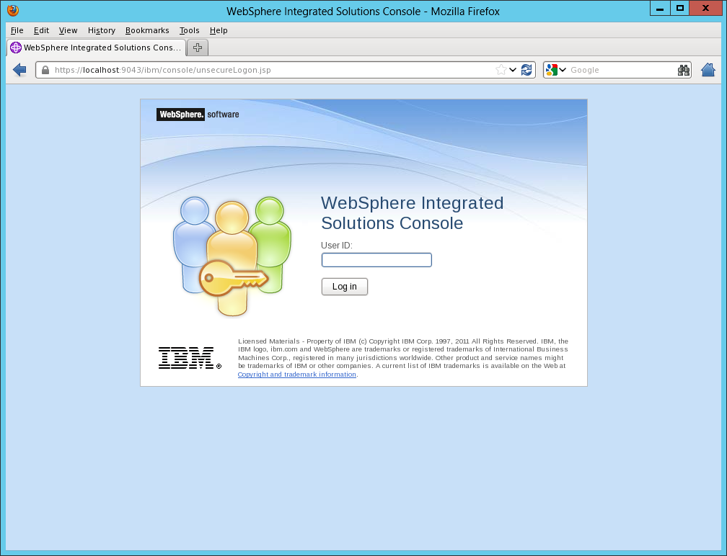  
Task 1 is complete!**

**Task 2: Start AgentNode**

Note: Run following command in the terminal first.

/opt/IBM/WebSphere/AppServer/profiles/AppSrv01/bin/startNode.sh

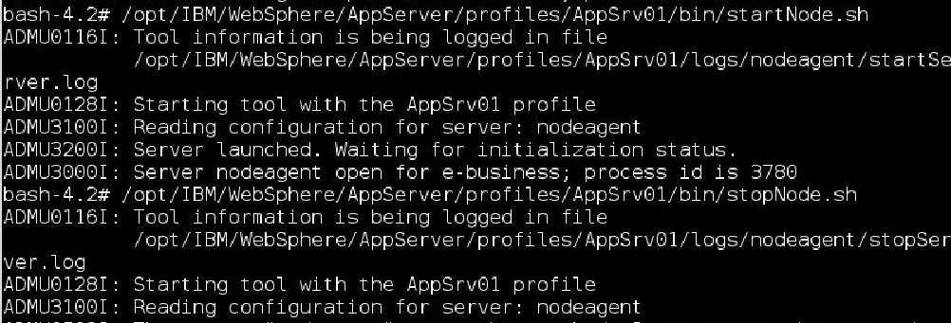

**Task 2 is complete!**

**Task 3: Stop & Start Application**

Ins. Console

Secure Console

Stop  
Appl.

Stop App Srv.

Stop Node A.

Stop DMGR



**Step 1:** Login to admin console. We set user “ernesto” as the user, you should use the one you set on the previous task.

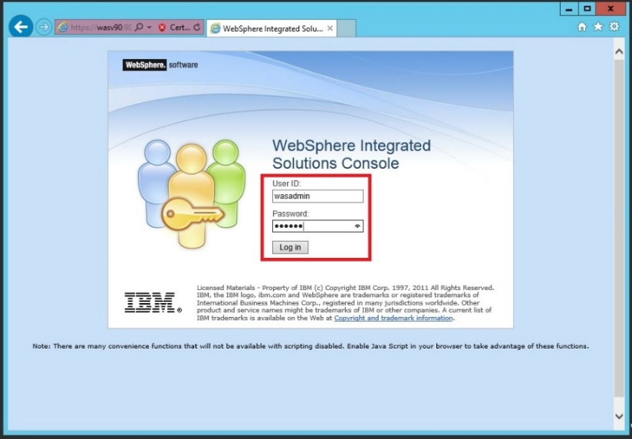

Ins. Console

Secure Console

Stop  
Appl.

Stop App Srv.

Stop Node A.

Stop DMGR



**Step 2:** Navigate to “Applications>All applications” to see the list of applications. Check the box next to the application you want to stop, select the option “Stop” as for “Action” and then click on “**Submit Action**” button.

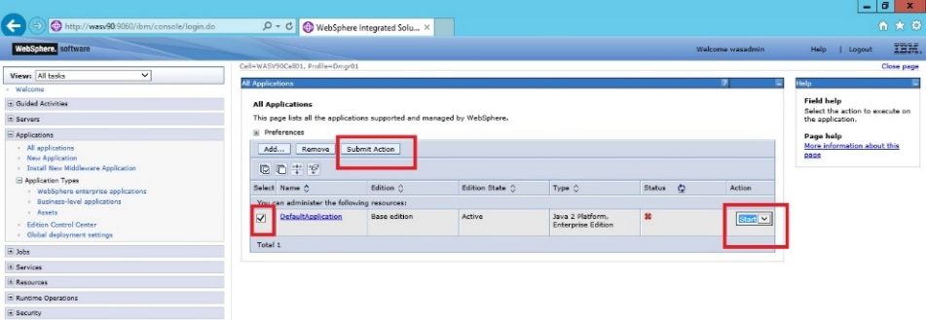

**Step 3:** You should see the successful message as shown below. Sometimes, it takes a while to see the change in the “Status” icon. You may click on “Refresh” button next to “Status” to see fresh state of the application. 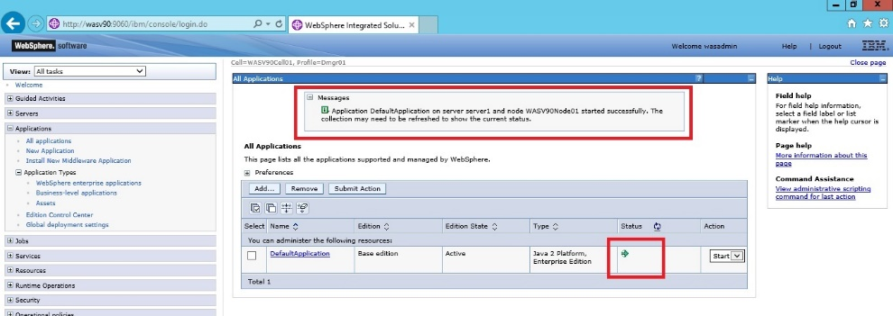

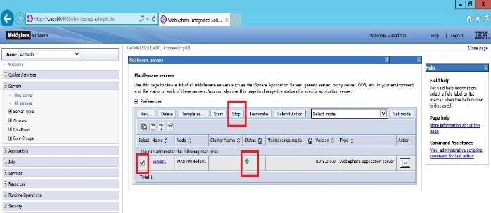

Ins. Console

Secure Console

Stop  
Appl.

Stop App Srv.

Stop Node A.

Stop DMGR



**Step 4:** Before starting any application, you need to be sure that the current status of the application must be stopped. Click on the check box of the application you want to start, choose the action “Start” and then click on “**Submit Action**”. **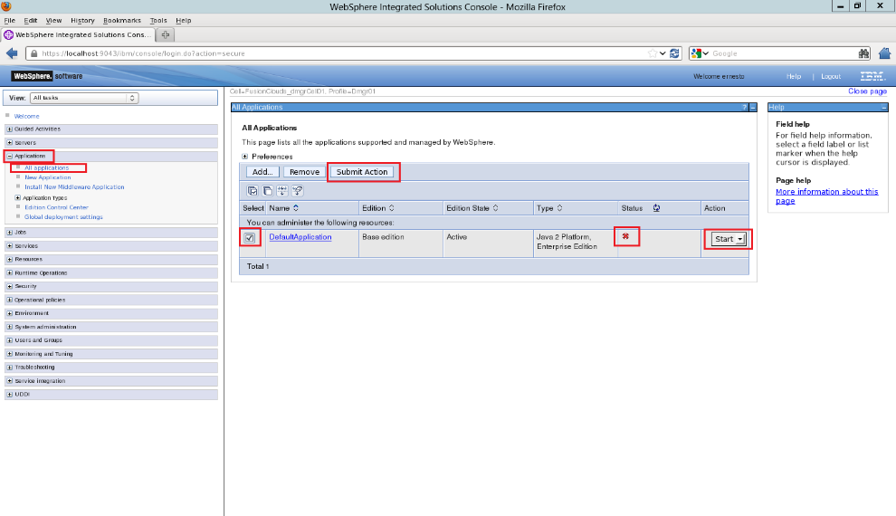  
Step 5:** You should see a success message as follows with status green. **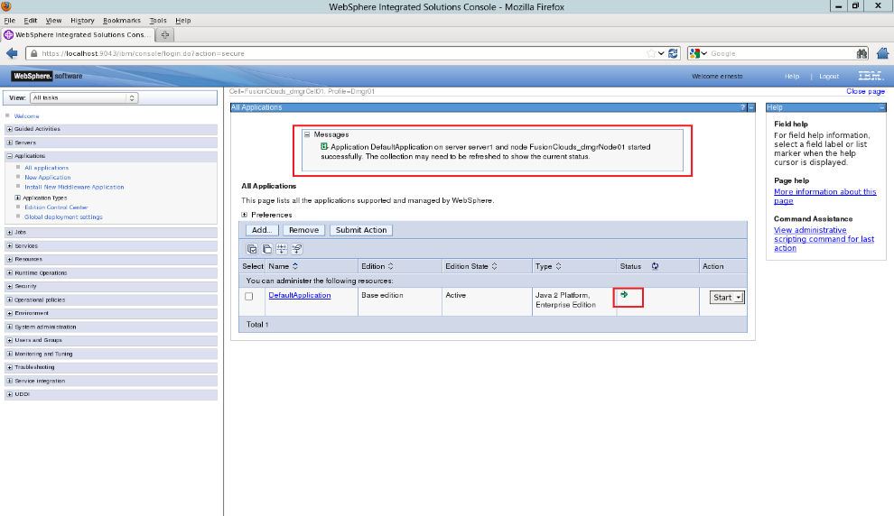  
Task 3 is complete!**

Ins. Console

Secure Console

Stop  
Appl.

Stop App Srv.

Stop Node A.

Stop DMGR



**Task 4: Stop & Start Application Server**

**Step 1:** Login to admin console using administrative user and password.  
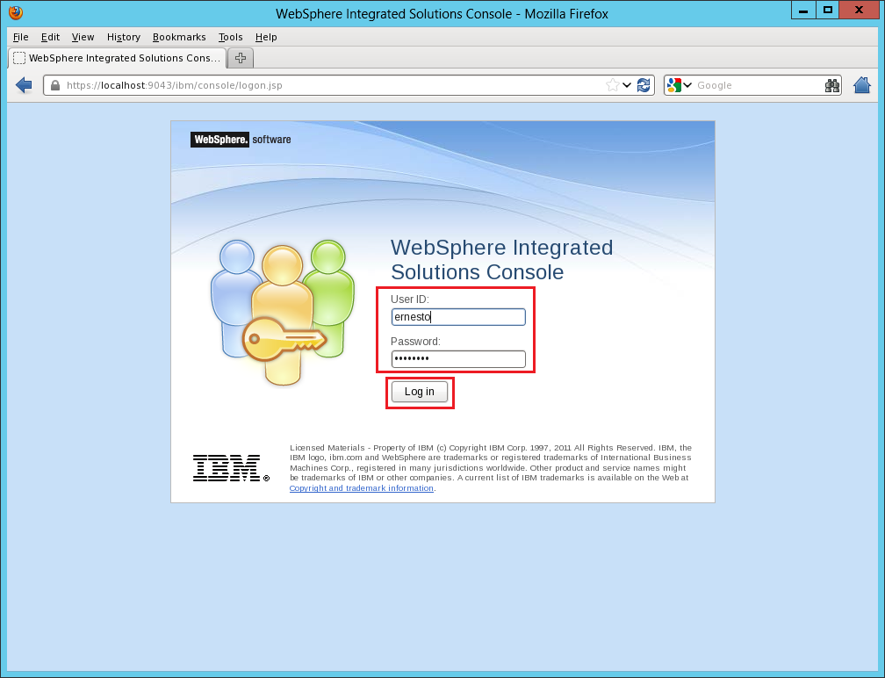

Ins. Console

Secure Console

Stop  
Appl.

Stop App Srv.

Stop Node A.

Stop DMGR



**Step 2:** Navigate to “Servers>Server Types>WebSphere application servers” to list the application servers. Mark the application server you want to stop and then click “**Stop**”.

**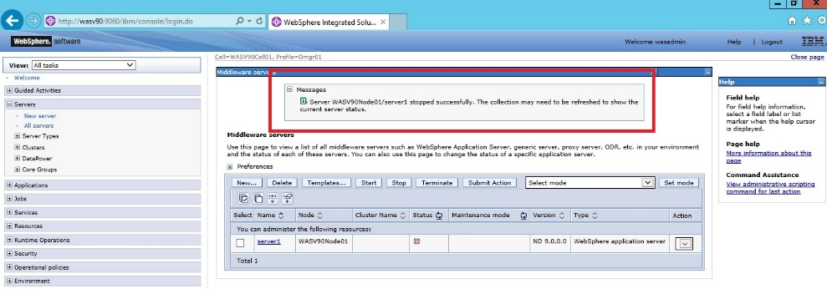   
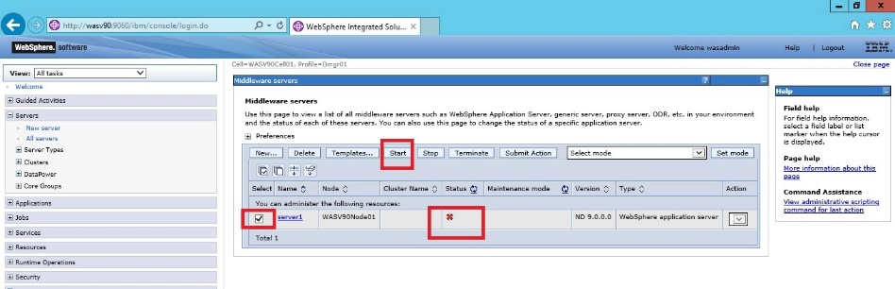**

**Step 3:** If this is the first time, you may see a confirmation message as follows. You can check “Do not show this message again” and then click on “**OK**”. 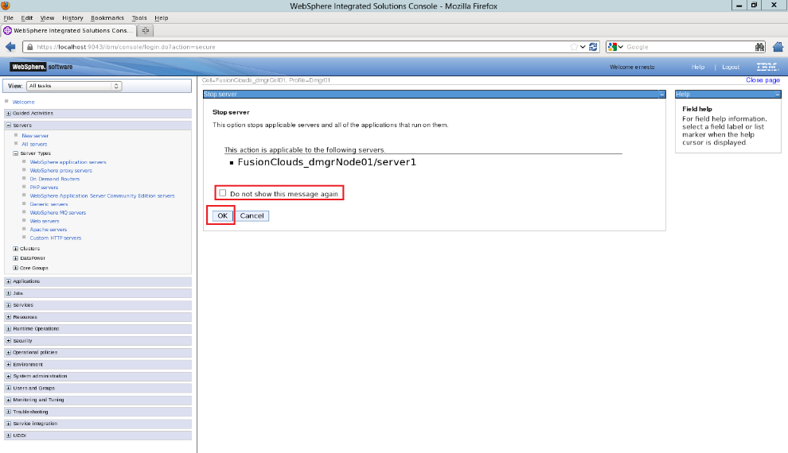

Ins. Console

Secure Console

Stop  
Appl.

Stop App Srv.

Stop Node A.

Stop DMGR



**Step 4:** You should see the success message as below. Click “**OK**” to continue.

**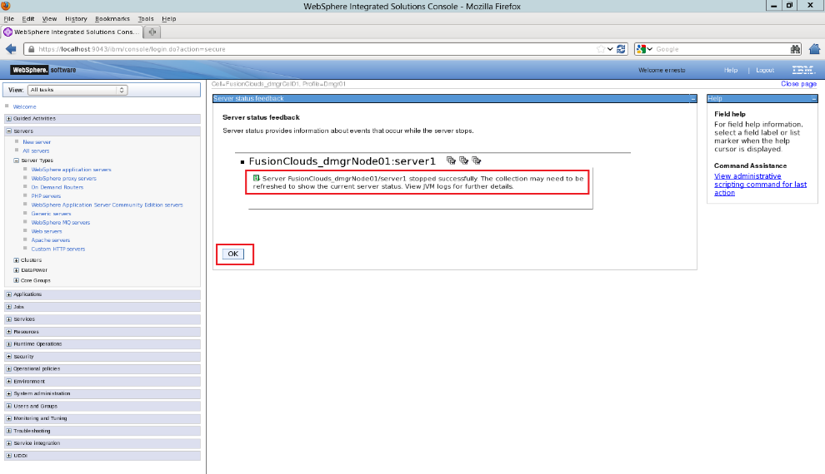  
Step 5:** Select the application server that you want to start under “Servers>Server Types>WebSphere application servers”, and then click on “**Start**”. 

Ins. Console

Secure Console

Stop  
Appl.

Stop App Srv.

Stop Node A.

Stop DMGR



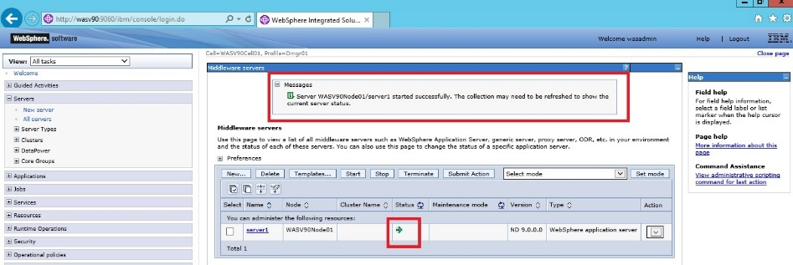**Step 6:** You should see the success message. **Task 4 is complete!**

**Task 5: Restart & Stop Node Agent**

Ins. Console

Secure Console

Stop  
Appl.

Stop App Srv.

Stop Node A.

Stop DMGR



**Step 1:** Login to admin console using administrative user and password.  


**Step 2:** Navigate to “System administration>Node agents” to see the list of node agents. Select the node agent you want to restart and then click on **“Restart**” button.

Ins. Console

Secure Console

Stop  
Appl.

Stop App Srv.

Stop Node A.

Stop DMGR



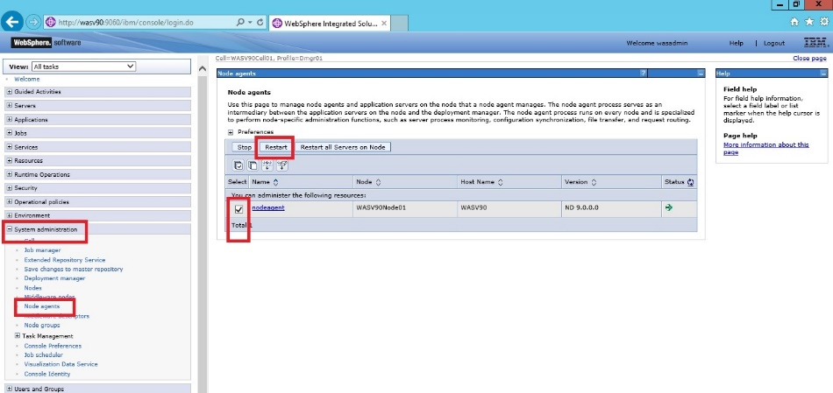

**Step 3:** You should see the success message as follows. You can click on status refresh button to see node agent up again.

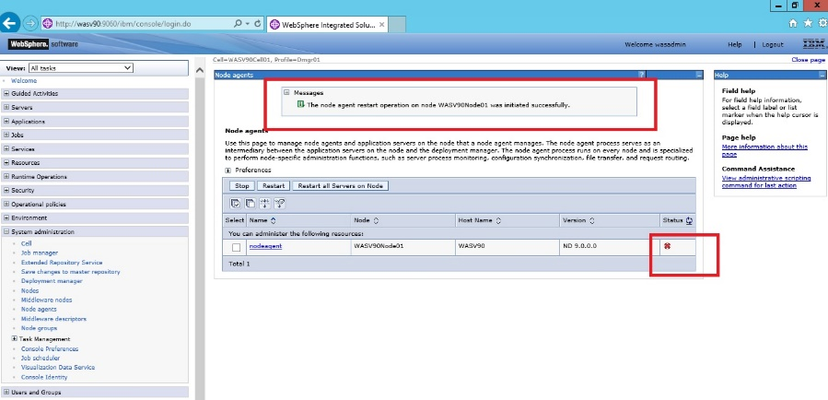

**Step 4:** Select the node agent you want to stop and then click on **“Submit”** button. **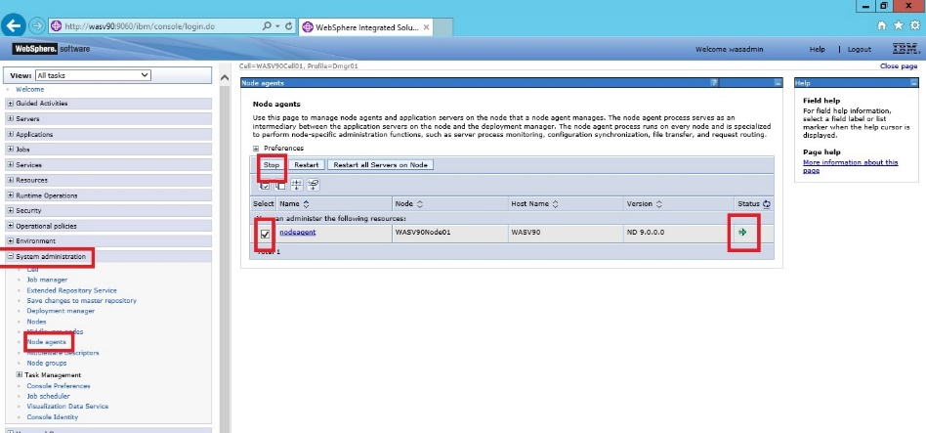  
Step 5:** You should see the success message.

Ins. Console

Secure Console

Stop  
Appl.

Stop App Srv.

Stop Node A.

Stop DMGR



**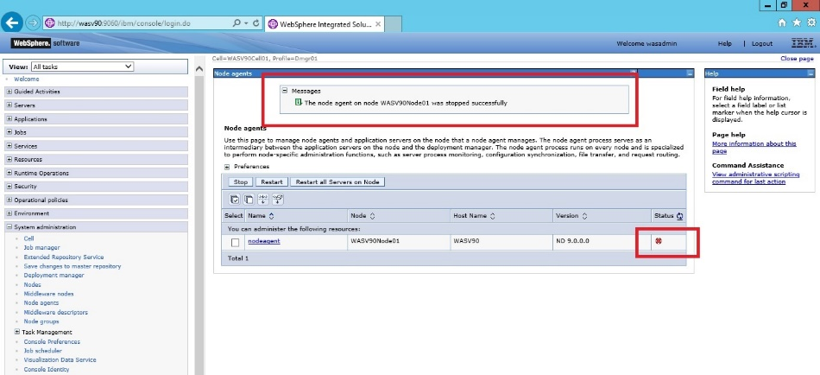  
Step 6:** Be careful about stopping node agent via admin console, because you have to use command line to start it again. You cannot take any further action for that node agent and servers and applications under it from admin console! 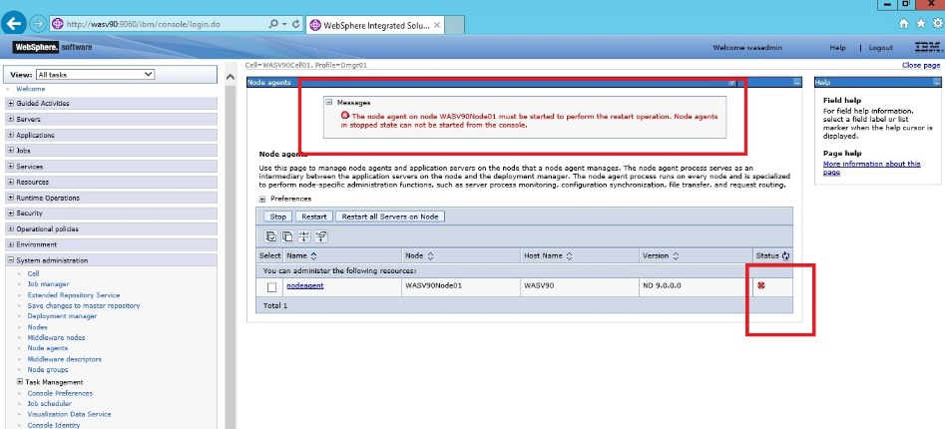

Ins. Console

Secure Console

Stop  
Appl.

Stop App Srv.

Stop Node A.

Stop DMGR



**Task 5 is complete!**

Ins. Console

Secure Console

Stop  
Appl.

Stop App Srv.

Stop Node A.

Stop DMGR



**Task 6: Stop Deployment Manager**

**Step 1:** Login to admin console using administrative user and password.  


Ins. Console

Secure Console

Stop  
Appl.

Stop App Srv.

Stop Node A.

Stop DMGR



**Step 2:** Navigate to “System administration>Deployment manager” and click **“Stop**” button.

**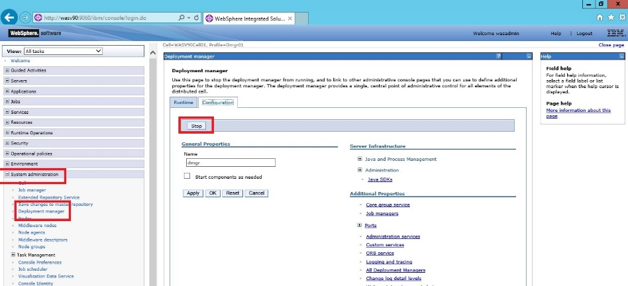  
Step 3:** Click on **“OK**” button to confirm to stop deployment manager. 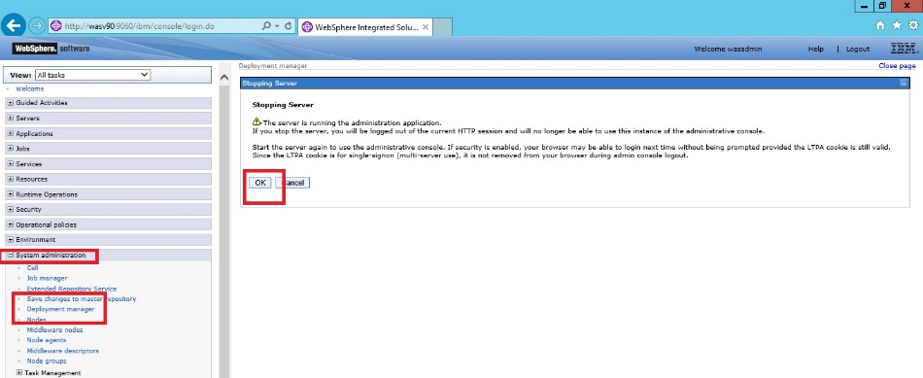

Ins. Console

Secure Console

Stop  
Appl.

Stop App Srv.

Stop Node A.

Stop DMGR



**Step 4:** You will see the following screen. There is no way to start deployment manager from graphical interface, you have to use command line to start it again.

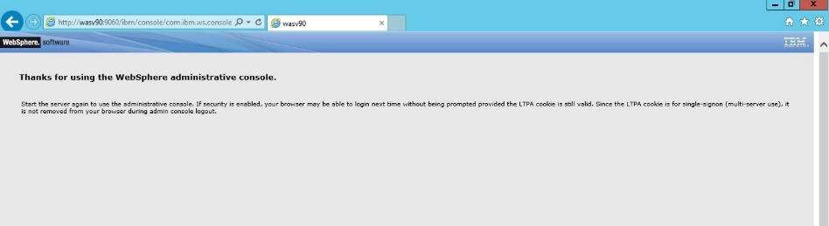

**Task 6 is complete!**

# SUMMARY

IBM WebSphere Application System provides a web based graphical user interface to perform administrative tasks. The official name for this tool is “WebSphere Integrated Solutions Console” but in many resources you may see different terms such as “admin console” and “administrative console” for the same interface. You can configure to use different realms to login admin console. Integrated Solutions Console also gives you the possibility to configure items on different scopes that are cell, node, server and application.

# REFERENCES

* http://pic.dhe.ibm.com/infocenter/wasinfo/v8r0/index.jsp?topic=%2Fcom.ibm.websphere.base.doc%2Finfo%2Faes%2Fae%2Ftsec_useregistry.html
* http://pic.dhe.ibm.com/infocenter/wasinfo/v8r5/index.jsp?topic=/com.ibm.websphere.ihs.doc/ihs/tihs_startadmserv.html